CARD 4
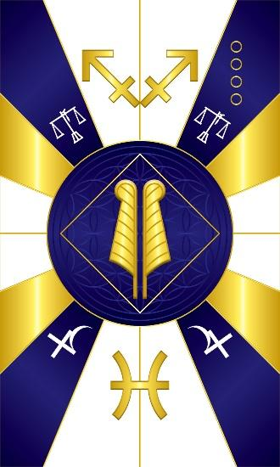
Aje Shaluga – wealth Aje - Goddess of Wealth

Aje Shaluga is the Yoruba deity of material wealth, money, currency, markets, and trade. In most places in Yorubaland, he is male, but in some places and much of the diaspora, she is female or androgynous, or their gender is not specified because it is not considered important. Her embodiment on most altars is a large cowrie shell. Often this is filled with coins and/or paper currency from many nations, jewels, or other valuables. Her sacred colors are blue and yellow/gold or yellow and green or yellow, green, and cream/beige.

Maat is the Kemetic deity of wealth. True wealth is having what you need when you need it. It could be money, friendship, health, etc. Her colors are Blue and White, so we blended the two and created a card of blue, yellow/gold, and white colors.

I the middle are two Ostrich feathers of Maat. Maat is usually seen with 1 and in the literature, the heart of the initiate is weighed against the feather to determine if their heart is as light as a feather, which shows that they have lived truth. When two feathers are combined, it makes up the imagery on the Atef Crown. It is the specific feathered white crown of the ancient Kemetic deity Ausar. It combines the white crown of Upper Egypt, with curly red ostrich feathers on each side of the crown. The feathers are identified as ostrich from their curl or curve at the upper ends, with a slight flare toward the base. They are the same feather as (singly) worn by Maat. Ausar wears the Atef crown as a symbol of the ruler of the underworld. The feathers represent truth and justice to which Maat corresponds.

They are surrounded by a square to convey the association to the number 4 to which Maat corresponds.

In the upper quadrants we have the scales which convey the weighing of truth. In the lower quadrants we have the astrological glyph for the planet Jupiter. At the top we have the symbol for the constellation of Sagittarius and at the bottom Pisces, which are both signs ruled by Jupiter.

Comments by Baba Awodele

